options =

[**TrainingOptionsSGDM**](matlab:helpPopup%20nnet.cnn.TrainingOptionsSGDM) with properties:

Momentum: 0.1000

InitialLearnRate: 1.0000e-03

LearnRateSchedule: 'none'

LearnRateDropFactor: 0.1000

LearnRateDropPeriod: 5

L2Regularization: 1.0000e-04

GradientThresholdMethod: 'l2norm'

GradientThreshold: Inf

MaxEpochs: 600

MiniBatchSize: 20

Verbose: 1

VerboseFrequency: 50

ValidationData: [1×1 augmentedImageDatastore]

ValidationFrequency: 4000

ValidationPatience: Inf

Shuffle: 'every-epoch'

CheckpointPath: ''

ExecutionEnvironment: 'gpu'

WorkerLoad: []

OutputFcn: []

Plots: 'training-progress'

SequenceLength: 'longest'

SequencePaddingValue: 0

SequencePaddingDirection: 'right'

DispatchInBackground: 0

ResetInputNormalization: 1

Initializing input data normalization.

|======================================================================================================================|

| Epoch | Iteration | Time Elapsed | Mini-batch | Validation | Mini-batch | Validation | Base Learning |

| | | (hh:mm:ss) | Accuracy | Accuracy | Loss | Loss | Rate |

|======================================================================================================================|

| 1 | 1 | 00:00:02 | 20.00% | 9.09% | 1.9873 | 1.9591 | 0.0010 |

| 17 | 50 | 00:00:45 | 45.00% | | 1.6729 | | 0.0010 |

| 34 | 100 | 00:01:34 | 55.00% | | 1.4580 | | 0.0010 |

| 50 | 150 | 00:02:24 | 60.00% | | 1.2924 | | 0.0010 |

| 67 | 200 | 00:03:10 | 60.00% | | 0.8858 | | 0.0010 |

| 84 | 250 | 00:03:56 | 80.00% | | 0.8075 | | 0.0010 |

| 100 | 300 | 00:04:43 | 60.00% | | 0.8995 | | 0.0010 |

| 117 | 350 | 00:05:34 | 90.00% | | 0.4655 | | 0.0010 |

| 134 | 400 | 00:06:25 | 70.00% | | 0.7665 | | 0.0010 |

| 150 | 450 | 00:07:15 | 70.00% | | 0.6288 | | 0.0010 |

| 167 | 500 | 00:08:04 | 80.00% | | 0.4415 | | 0.0010 |

| 184 | 550 | 00:08:56 | 80.00% | | 0.5591 | | 0.0010 |

| 200 | 600 | 00:09:45 | 65.00% | | 1.0167 | | 0.0010 |

| 217 | 650 | 00:10:37 | 75.00% | | 1.0653 | | 0.0010 |

| 234 | 700 | 00:11:30 | 95.00% | | 0.1762 | | 0.0010 |

| 250 | 750 | 00:12:19 | 90.00% | | 0.2827 | | 0.0010 |

| 267 | 800 | 00:13:10 | 90.00% | | 0.2952 | | 0.0010 |

| 284 | 850 | 00:14:02 | 95.00% | | 0.1658 | | 0.0010 |

| 300 | 900 | 00:14:53 | 95.00% | | 0.2534 | | 0.0010 |

| 317 | 950 | 00:15:44 | 90.00% | | 0.2168 | | 0.0010 |

| 334 | 1000 | 00:16:36 | 100.00% | | 0.0702 | | 0.0010 |

| 350 | 1050 | 00:17:29 | 100.00% | | 0.0907 | | 0.0010 |

| 367 | 1100 | 00:18:21 | 100.00% | | 0.0430 | | 0.0010 |

| 384 | 1150 | 00:19:12 | 95.00% | | 0.1326 | | 0.0010 |

| 400 | 1200 | 00:20:05 | 100.00% | | 0.0593 | | 0.0010 |

| 417 | 1250 | 00:21:03 | 100.00% | | 0.0849 | | 0.0010 |

| 434 | 1300 | 00:22:09 | 100.00% | | 0.0174 | | 0.0010 |

| 450 | 1350 | 00:23:09 | 100.00% | | 0.0230 | | 0.0010 |

| 467 | 1400 | 00:24:03 | 100.00% | | 0.0728 | | 0.0010 |

| 484 | 1450 | 00:24:56 | 100.00% | | 0.0591 | | 0.0010 |

| 500 | 1500 | 00:25:49 | 100.00% | | 0.0061 | | 0.0010 |

| 517 | 1550 | 00:26:40 | 100.00% | | 0.0299 | | 0.0010 |

| 534 | 1600 | 00:27:32 | 100.00% | | 0.0154 | | 0.0010 |

| 550 | 1650 | 00:28:25 | 100.00% | | 0.0127 | | 0.0010 |

| 567 | 1700 | 00:29:16 | 100.00% | | 0.0187 | | 0.0010 |

| 584 | 1750 | 00:30:08 | 100.00% | | 0.0166 | | 0.0010 |

| 600 | 1800 | 00:30:59 | 100.00% | 69.70% | 0.0071 | 1.2479 | 0.0010 |

|======================================================================================================================|

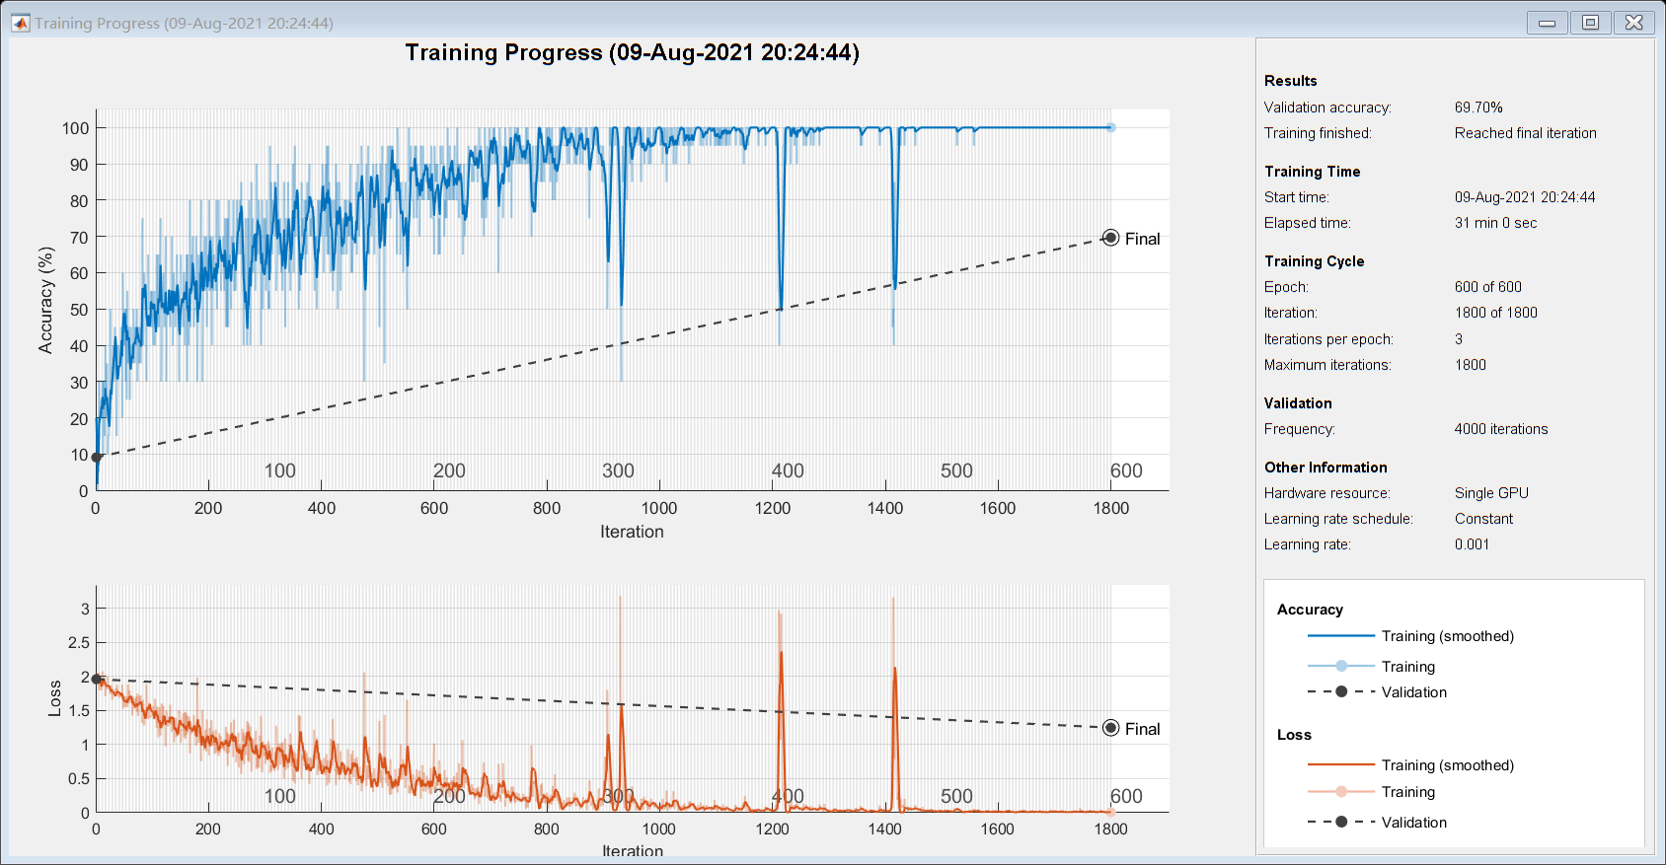

net =

[**DAGNetwork**](matlab:helpPopup%20DAGNetwork) with properties:

Layers: [144×1 nnet.cnn.layer.Layer]

Connections: [170×2 table]

InputNames: {'data'}

OutputNames: {'output'}

traininfo = struct with fields:

TrainingLoss: [1×1800 double]

TrainingAccuracy: [1×1800 double]

ValidationLoss: [1×1800 double]

ValidationAccuracy: [1×1800 double]

BaseLearnRate: [1×1800 double]

FinalValidationLoss: 1.2479

FinalValidationAccuracy: 69.6970

Error using [**nnet.internal.cnn.util.validateLayersForLayerGraph>iAssertUniqueAndNonEmptyLayerNames**](matlab:matlab.internal.language.introspective.errorDocCallback('nnet.internal.cnn.util.validateLayersForLayerGraph%3eiAssertUniqueAndNonEmptyLayerNames',%20'C:\Program%20Files\Polyspace\R2020a\toolbox\nnet\cnn\+nnet\+internal\+cnn\+util\validateLayersForLayerGraph.m',%2056)) ([line 56](matlab:%20opentoline('C:\Program%20Files\Polyspace\R2020a\toolbox\nnet\cnn\+nnet\+internal\+cnn\+util\validateLayersForLayerGraph.m',56,0)))  
Layer names in layer array must be different from the names of layers in layer graph.

Error in [**nnet.internal.cnn.util.validateLayersForLayerGraph**](matlab:matlab.internal.language.introspective.errorDocCallback('nnet.internal.cnn.util.validateLayersForLayerGraph',%20'C:\Program%20Files\Polyspace\R2020a\toolbox\nnet\cnn\+nnet\+internal\+cnn\+util\validateLayersForLayerGraph.m',%2033)) ([line 33](matlab:%20opentoline('C:\Program%20Files\Polyspace\R2020a\toolbox\nnet\cnn\+nnet\+internal\+cnn\+util\validateLayersForLayerGraph.m',33,0)))  
iAssertUniqueAndNonEmptyLayerNames(larray, existingLayers);  
  
Error in [**nnet.cnn.LayerGraph>iValidateLayers**](matlab:matlab.internal.language.introspective.errorDocCallback('nnet.cnn.LayerGraph%3eiValidateLayers',%20'C:\Program%20Files\Polyspace\R2020a\toolbox\nnet\cnn\+nnet\+cnn\LayerGraph.m',%20556)) ([line 556](matlab:%20opentoline('C:\Program%20Files\Polyspace\R2020a\toolbox\nnet\cnn\+nnet\+cnn\LayerGraph.m',556,0)))  
larray = nnet.internal.cnn.util.validateLayersForLayerGraph(larray, existingLayers);  
  
Error in [**nnet.cnn.LayerGraph/addLayers**](matlab:matlab.internal.language.introspective.errorDocCallback('nnet.cnn.LayerGraph/addLayers',%20'C:\Program%20Files\Polyspace\R2020a\toolbox\nnet\cnn\+nnet\+cnn\LayerGraph.m',%20190)) ([line 190](matlab:%20opentoline('C:\Program%20Files\Polyspace\R2020a\toolbox\nnet\cnn\+nnet\+cnn\LayerGraph.m',190,0)))  
larray = iValidateLayers(larray, existingLayers);